**Designing a Logical Data Model**

Business Description

Business background : The company is Climbs for mountaineering club, we have about 5 years experience. The club organizes various climbing expeditions and activities, ranging from beginner-level hikes to challenging mountain ascents. As the club continues to grow and attract more members, there is a need to establish a comprehensive database to manage and track the climbs undertaken by club members.

Problems. Current situation: Problems here troubling managing data about climbers their each climb, mountain and defining their current location and so on

The benefits of implementing a database. Project vision: There is several benefits of implementing database, it improves data organization, enhances data accessibility, sometimes it helps to easy and useful decision making, and it helps if there promotions of club community

Model description

Definitions:

Climb: Climbers each climb on mountain

Mountain: A large landform for climb

Climber: A person who climbs and activities in mountaineering

Climb_id: A unique identifier

Name: Name of each climber

Address: Physical address of climver

Mountain_id: Unique identifier for mountain

Area: Area of mountain

For keys: Used Primary key for unique identifier

Foreign key: Showing relationship between tables

Logical scheme:

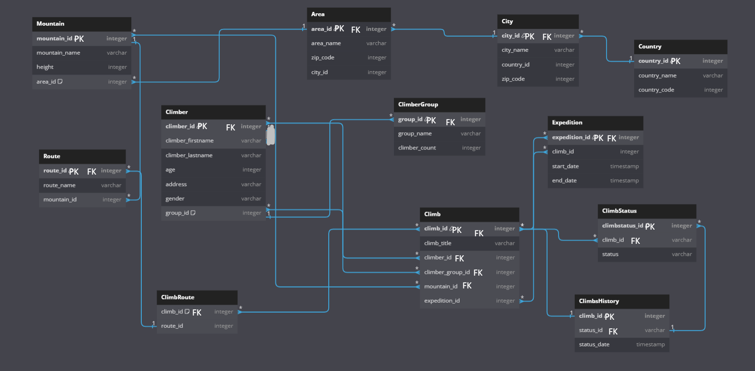

Objects

There is more than 10 tables described

Mountain: data about mountain

Area: Area of mountain

City: City of Mountain

Country: Country of Mountain

Route: Route of Mountain that climber used to climb to mountain

Climber: Full data about each climber

Climber group: It is for describing which climber in which group

Expedition: Beginning and end of the climb

ClimbRoute, Climb and ClimbStatus: All about full data about climb and climb status that finished or in progress

And last is ClimbHistory which describes history of each climb of climber

Table Description

<description>

|  |  |  |  |
| --- | --- | --- | --- |
| Table Name | Field name | Field Description | Data Type |
| Mountain | Mountain_id | PK | Int |
| Mountain_name |  | varchar |
| height |  | Int |
| Area id | FK to Area | int |

|  |  |  |  |
| --- | --- | --- | --- |
| Table Name | Field name | Field Description | Data Type |
| Area | area_id | PK | Int |
| area_name |  | varchar |
| Zip_code |  | Int |
| city id | FK to City | int |

|  |  |  |  |
| --- | --- | --- | --- |
| Table Name | Field name | Field Description | Data Type |
| City | city_id | PK | Int |
| city_name |  | varchar |
| Country_id | FK to country | Int |
| Zip_code |  | int |

|  |  |  |  |
| --- | --- | --- | --- |
| Table Name | Field name | Field Description | Data Type |
| Country | Country _id | PK | Int |
| Country _name |  | varchar |
| Country _code |  | int |

|  |  |  |  |
| --- | --- | --- | --- |
| Table Name | Field name | Field Description | Data Type |
| Route | Route _id | PK | Int |
| Route _name |  | Varchar |
|  | mountain_id | FK to mountain | Int |

|  |  |  |  |
| --- | --- | --- | --- |
| Table Name | Field name | Field Description | Data Type |
| Climber | Climber _id | PK | Int |
| Climber _name |  | varchar |
| age |  | Int |
| Group_id | FK to mountain | int |

|  |  |  |  |
| --- | --- | --- | --- |
| Table Name | Field name | Field Description | Data Type |
| ClimberGroup | ClimberGroup _id | PK | Int |
| group _name |  | varchar |
| Climber_count |  | Int |
|  |  |  |

|  |  |  |  |
| --- | --- | --- | --- |
| Table Name | Field name | Field Description | Data Type |
| Expedition | Expedition _id | PK FK to climb | Int |
| climb _id |  | int |
| Start date |  | timestamp |
| End date |  | timestamp |

|  |  |  |  |
| --- | --- | --- | --- |
| Table Name | Field name | Field Description | Data Type |
| ClimbRoute | ClimbRoute _id | FK to climb mountain | Int |
| route _id | FK mountain | int |
|  |  |  |
|  |  |  |

|  |  |  |  |
| --- | --- | --- | --- |
| Table Name | Field name | Field Description | Data Type |
| Climb | Climb _id | PK FK to climb mountain | Int |
| Climb _title |  | varchar |
| Climber_id | FK climber | int |
| Climb_group_id | FK group | int |
|  | Mounintain_id | FK mountain | int |
|  | Expedition_id | FK expedition | int |

|  |  |  |  |
| --- | --- | --- | --- |
| Table Name | Field name | Field Description | Data Type |
| Climb status | Climb status _id | PK | Int |
| Climb_id | FK climb | int |
|  |  |  |
|  |  |  |

|  |  |  |  |
| --- | --- | --- | --- |
| Table Name | Field name | Field Description | Data Type |
| Climb history | Climb _id | PK | Int |
| status_id | FK status | int |
|  |  |  |
|  |  |  |